A Project Report
on
“AI Recruiter – Shortlist a Suitable candidate for specific Job role (Using Node-RED and Personality Insights)”

By
TEAM: TEAM STAR
P. SAI SAVITHRU MOHAN (TEAM HEAD)

UNDER THE GUIDANCE OF

SMARTBRIDGE
 | CONTENTS
 |  | Page no.
 | 1. INTRODUCTION | 3
 | 1.1 Overview
 | 1.2 Purpose
 | 2. LITERATURE SURVEY | 5
 | 2.1 Existing Problem
 | 2.2 Proposed Solution
 | 3. THEORETICAL ANALYSIS | 6
 | 3.1 Block Diagram
 | 3.2 Hardware / Software Designing
 | 4. EXPERIMENTAL INVESTIGATIONS | 8
 | 5. FLOW CHART | 18
 | 6. RESULTS | 19
 | 7. ADVANTAGES & DISADVANTAGES | 23
 | 8. APPLICATIONS | 24
9. CONCLUSION 25
10. FUTURE SCOPE 26
11. BIBILOGRAPHY 26
SOURCE CODE 27

CHAPTER 1

INTRODUCTION

1.1 OVERVIEW

With the breakthrough of emerging technologies like Artificial Intelligence (AI), Data Science, Data Analytics, Cloud Computing, Internet of Things (IoT), Machine Learning, a large number of job opportunities are created these days and a lot more are expected in the future. Hence choosing the right candidate for right work has become very important and a key factor for the welfare and harmony of the organizations. But interacting, interviewing and screening the right candidate became a very difficult job for the Recruiters and Human Resources (HRs).

Artificial Intelligence enabled and empowered systems can definitely stand as a solution for this problem and moreover, saves energy, time and money for the recruiters and the recruiting companies as well. Artificial Intelligence enabled and empowered recruiter, AI Recruiter can interact with a very large number in very small duration of time with high accuracy and stands as a helping hand for the recruiters in selecting the right candidate for the job. It uses the most efficient and interactive Artificial Intelligence (AI) services like Node-RED, IBM Personality Insights and Cloudant. This project deals with the efficient way of implementing these services to develop a user-friendly User Interface (UI) that can be used for screening the candidates and choosing the right bunch for interview or job directly based on their skills and insights.

- Project Requirements and Skills Required: Java Script Object Notation (JSON), IBM Personality Insights, Cloudant and Node-RED.
- Functional Requirements: IBM Cloud (Account).
- Technical Requirements: Java Script Object Notation (JSON), IBM Services.
- Software Requirements: IBM Services.
- Project Category: Artificial Intelligence.
- Project Deliverables: AI Recruiter that could shortlist eligible candidates for specific job using interactive UI and insights provided by Personality Insights.
- Project By: Pishka Sai Savithru Mohan.

1.1.1 SCOPE OF WORK
- Create a Node-RED flow for interactive UI.
- Creating IBM Personality Insights Service.
- Build logic for interacting and screening the eligible candidates by integrating Personality Insights with Node-RED.
1.2 PURPOSE

With the increasing number of job-seekers in different industries it has become a hectic and colossal task for the recruiters or the employers to hire the suitable and eligible candidate to get their work done. Recruiters can interview each applied candidate but it consumes a lot of time, energy and money. Sometimes the situation gets even more complicated when candidates to be interviewed are in very large numbers and just becomes impossible for the employer or recruiter to pick the right candidate. In such situations, AI Recruiter comes into play and becomes handy for recruiters. These AI enabled recruiters can interact with any number of candidates and identify the skills of candidate using a form-based application and can screen the candidates for having a final interview with recruiter or hiring them directly based upon the insights this AI Recruiter brings with the help of Personality insights and the responses given by the candidates. This project thus serves to solve the issue in screening or short-listing the candidates for specific job role, because in most cases candidates’ resumes go unnoticed.

CHAPTER 2

LITERATURE SURVEY

2.1 EXISTING PROBLEM

The key factor for the success and welfare of any organization or industry is their employees. In the quest of picking the right employees, organizations are spending a lot of time, money and energy. The recruiters and employers find it impossible when the number of candidates to be interviewed is quite large. Though few organizations use screening systems, these can sometimes be manipulated by stuffing with a lot of keywords. And moreover there is no proper methodology or system to screen the candidates depending upon the candidate’s reply and few existing solutions (systems or methodologies) cannot make their own judgements and bring insights like a human recruiter can do in the interview.

2.2 PROPOSED SOLUTION

The solution for interviewing a large number of candidates who applied for a specific job without the involvement of recruiters and employers is AI Recruiter. This project serves to solve this issue. Moreover, AI Recruiter can make its own independent decisions depending upon the user answers and also brings insights using Personality Insights about the candidate that the recruiter can use and review if needed. It provides candidates with a user-friendly UI that can be used for answering the pre-defined questions and the AI Recruiter can screen the right candidates for further rounds or interview by judging the worth of the candidate on its own by calculating the score of the candidate and also provides us a user-friendly user interface (UI) and helps the candidates express themselves without any barriers.

CHAPTER 3

THEORETICAL ANALYSIS

3.1 BLOCK DIAGRAM

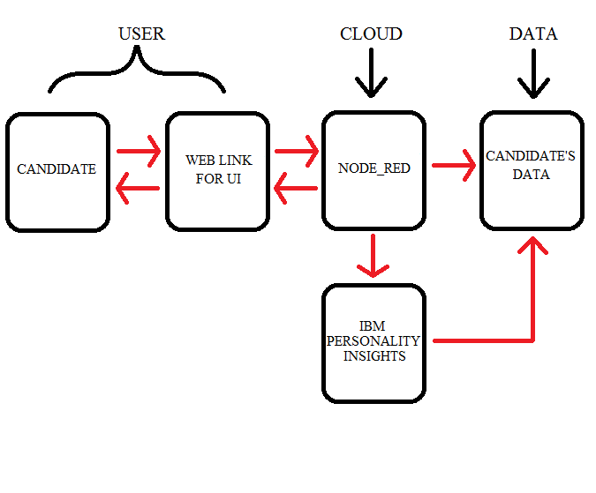

Fig. 3.1 Block Diagram of Artificial Intelligence(AI) Recruiter using Node-RED

The candidates who are interested in the job should submit the forms using Web link. The submitted info will be processed by Node-RED and creates a document for the candidate. Candidate can start taking interview by logging in and enter the details, skills asked and these details will be stored in the database and also data will be sent to Personality Insights and generates Insights which will be stored in the document and can be later viewed at any point of time by the recruiter to get a clear and better understanding of the candidate. The special feature of this AI Recruiter is the registered candidate can only take the interview once and prevents him in logging back again if he had already submitted. This provides the loyalty and trust that recruiters can count on this AI Recruiters.

IBM Personality Insights Service is based on the ‘Big 5 Personality theory’, which is a psychology theory that helps in understanding the particular individual’s traits. The five main traits are Openness, Conscientiousness, Extraversion, Agreeableness and Emotional Range. These traits have sub-categories which can be used for detail study about the candidate. For different traits the candidate can be judged, i.e., if the candidate has a percentile greater then a defined percentile then he will be eligible and needs to get good score for skills.

3.2 HARDWARE / SOFTWARE DESIGNING

1. Create ‘IBM Cloud Service’ Account.
2. Create Personality Insights Service.
3. Configuring Cloudant Service.
4. Design and create a flow in Node-RED.

CHAPTER 4

EXPERIMENTAL INVESTIGATIONS

4.1 CREATING IBM CLOUD SERVICES
Once we create an IBM Cloud Account the next important step required to develop an Artificial Intelligence Recruiter involves the following steps:
- Creation of Personality Insights Service.
- Creation and Configuration of Node-RED Service.

4.1.1 CREATION OF PERSONALITY INSIGHTS
1. Log in to IBM Cloud and open Catalog, search for Personality Insights and click on it.
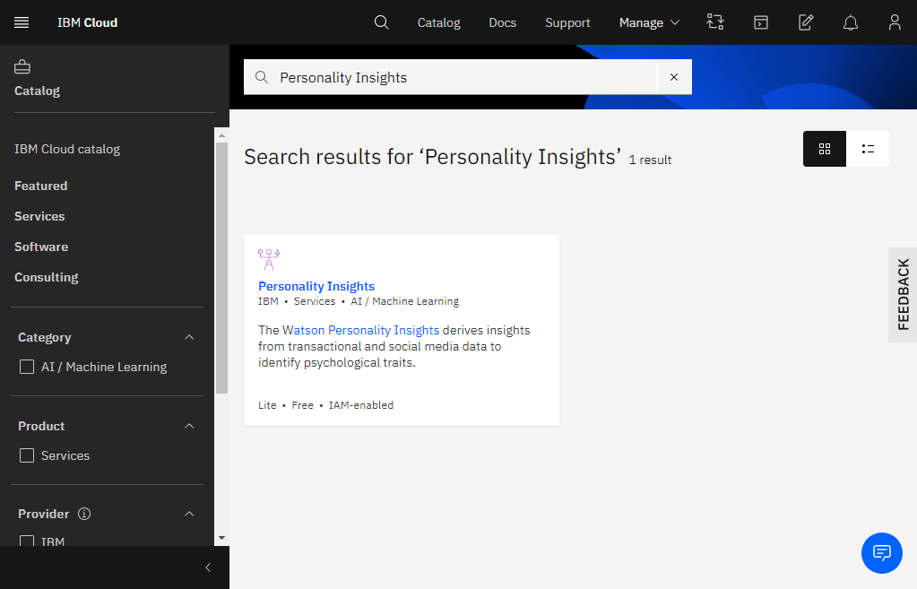
2. Choose the region and change Service name if needed and click Create.
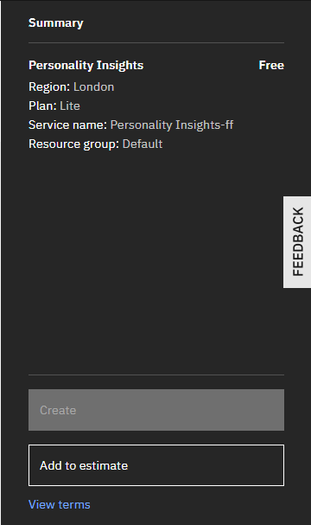
3. Go to IBM Dashboard and click Services and then click Personality Insights instance under it and save the credentials (API Key and URL) under the Service credentials tab.
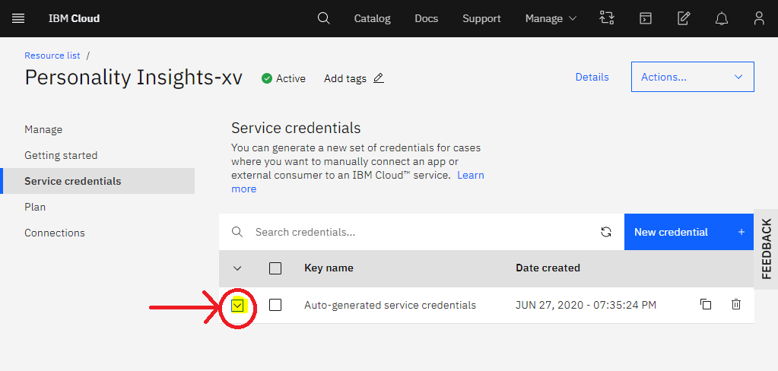

4.1.2 CREATION OF NODE-RED
1. Log in to IBM Cloud and open Catalog and search for Node-RED app in the software tab.
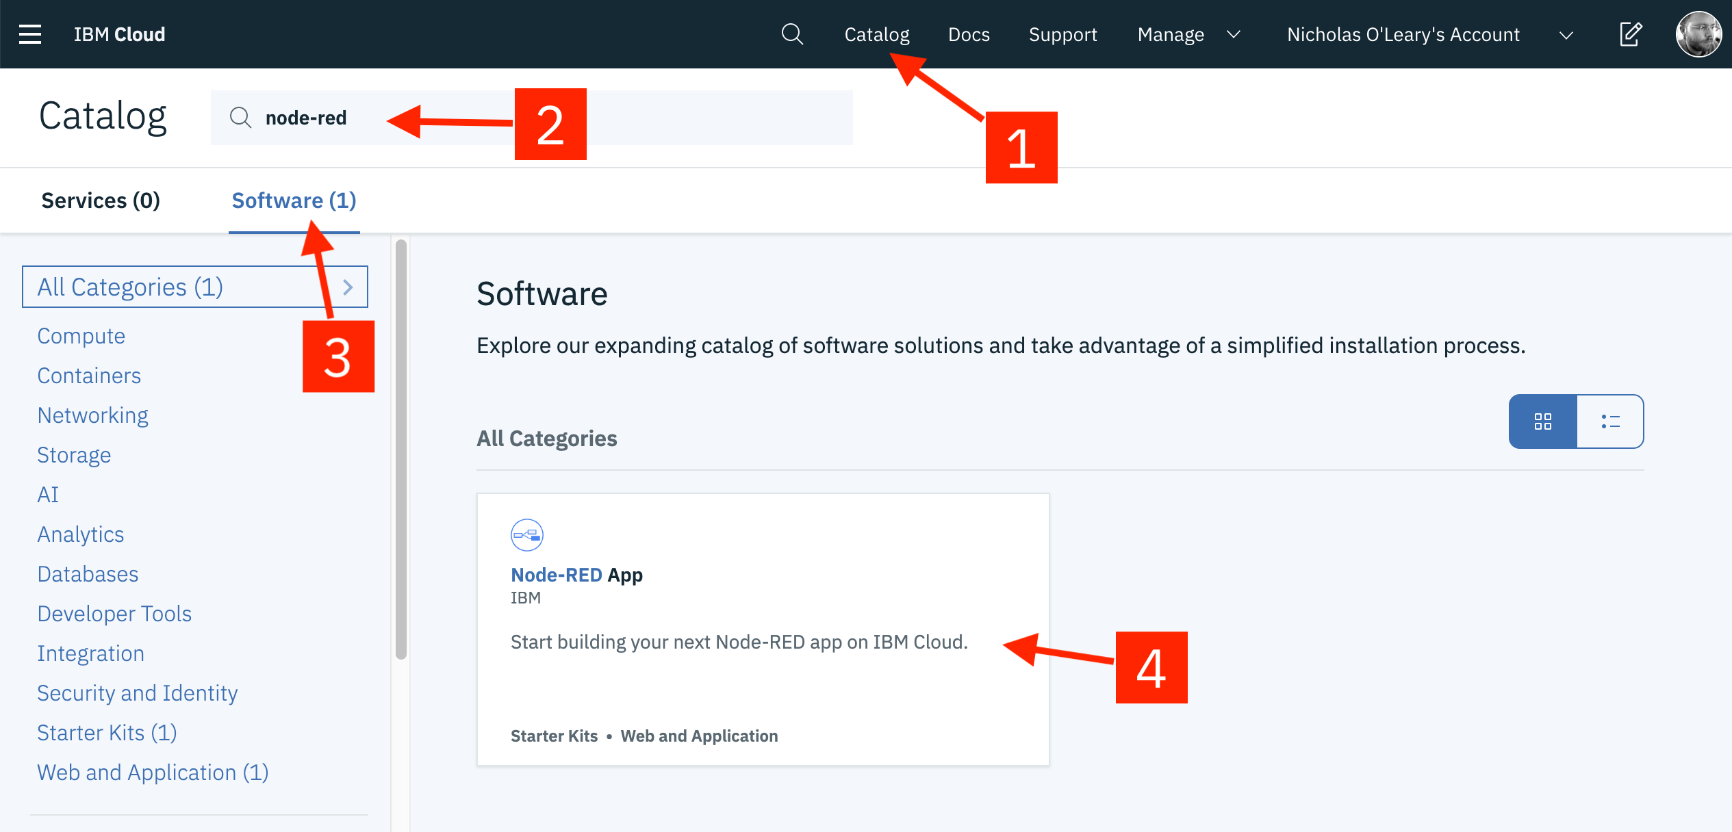
2. Click on the Create app

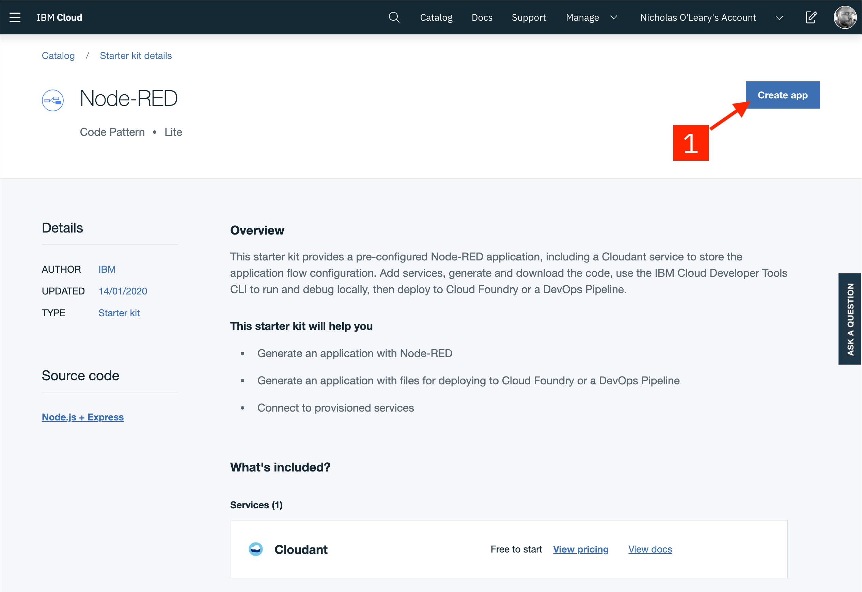
3. On the App details page, a name will be suggested for the app, accept it or modify it and name must be unique if modified.
4. Choose your Region and Service Plan and click Create.
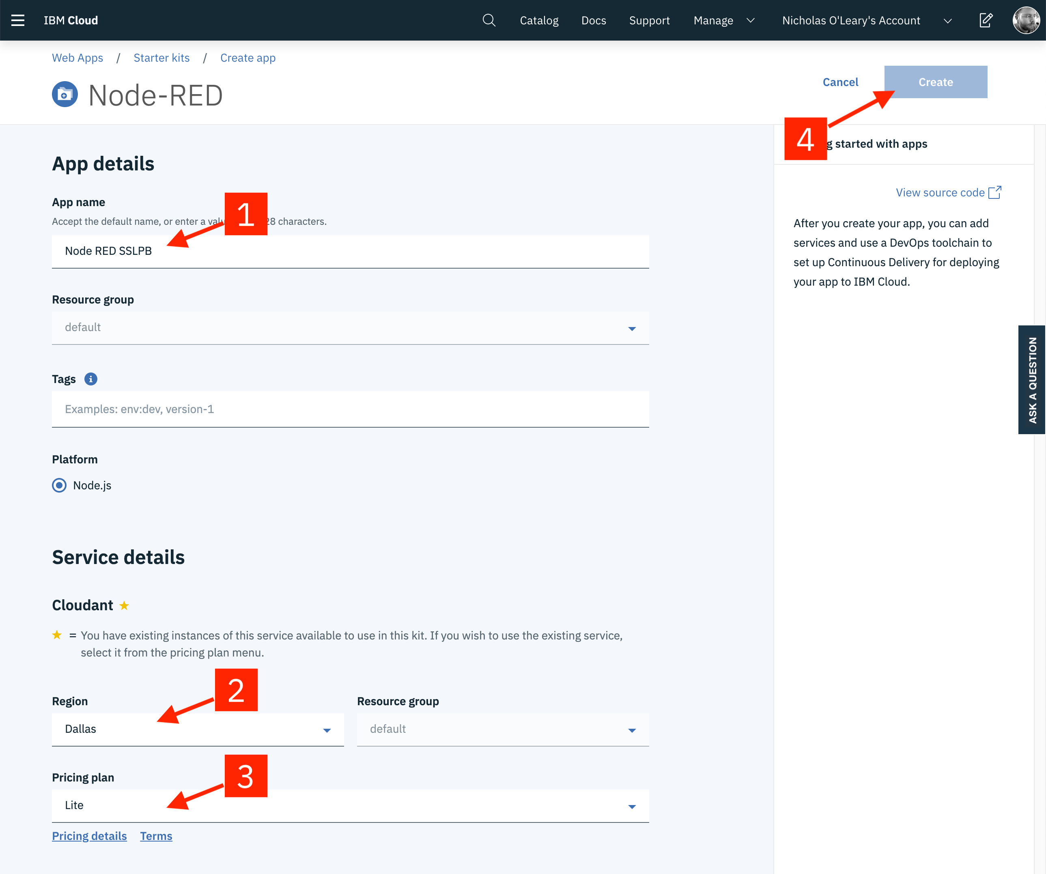
5. In the next page, click Deploy your app to enable Continuous Delivery feature.
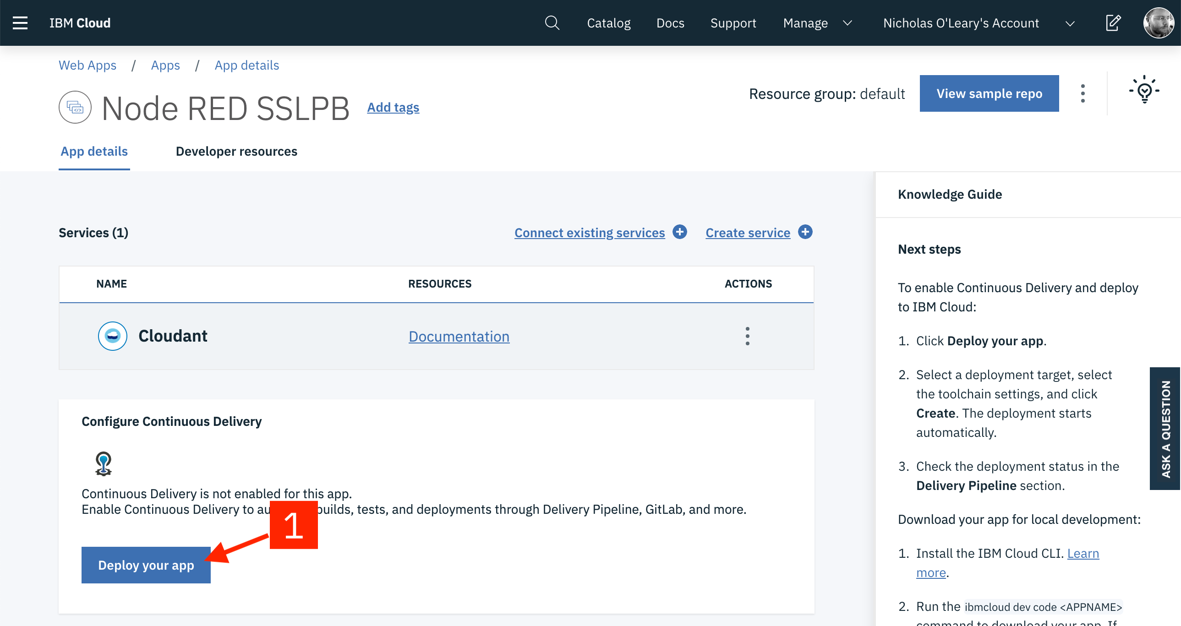
6. We need API key to access the resources, so click New in the next page under IBM Cloud API Key section and drag memory limit o 256 MB and choose region and click create.
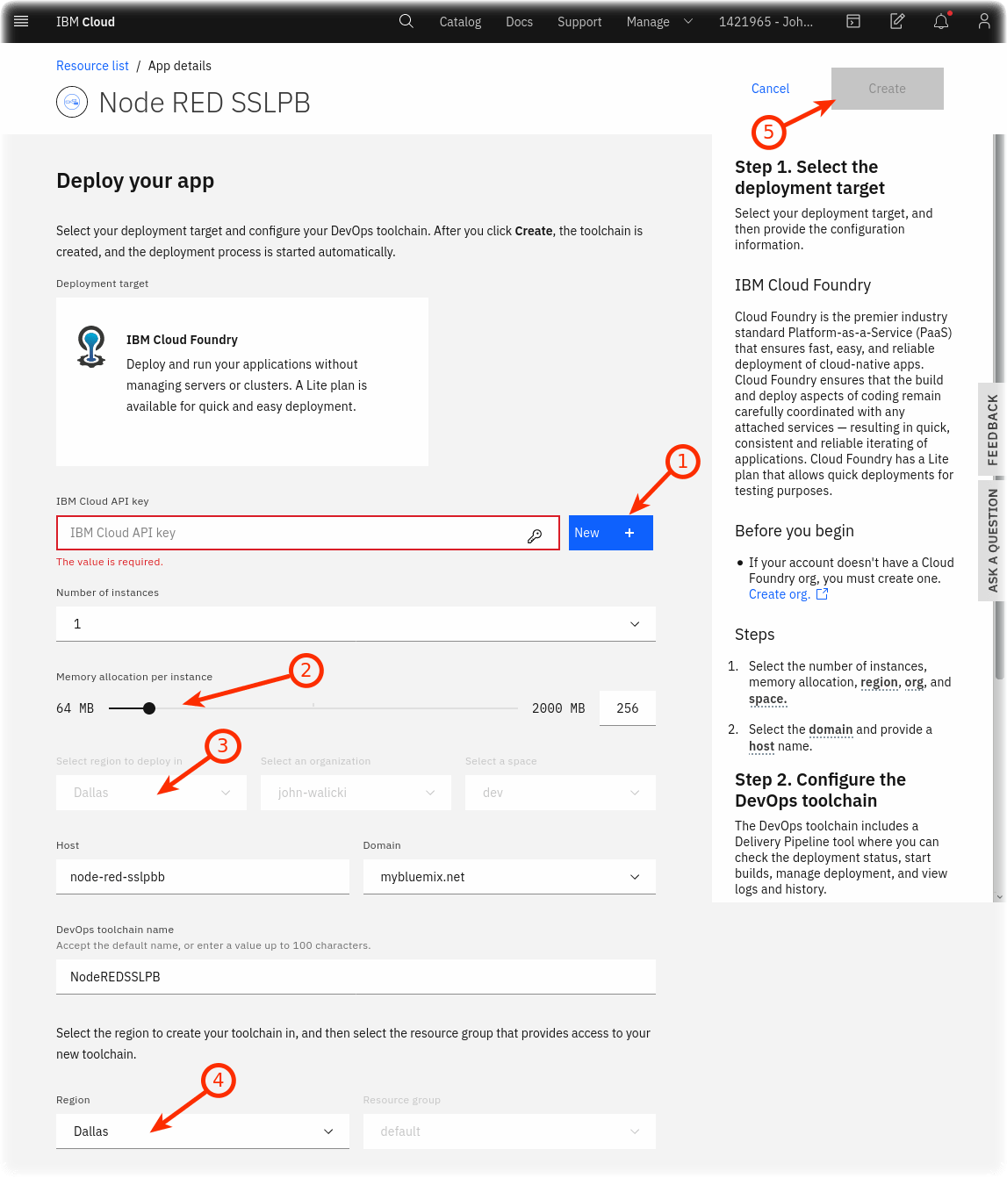
7. The page gets reloaded and shows the status of Delivery Pipeline. Click on In progress to see the full status. Here the Deploy stage takes few minutes to get passed. It means now it is ready to work.

8. Go to Resource page, and find for Node-RED in Cloud Foundry apps or app section.
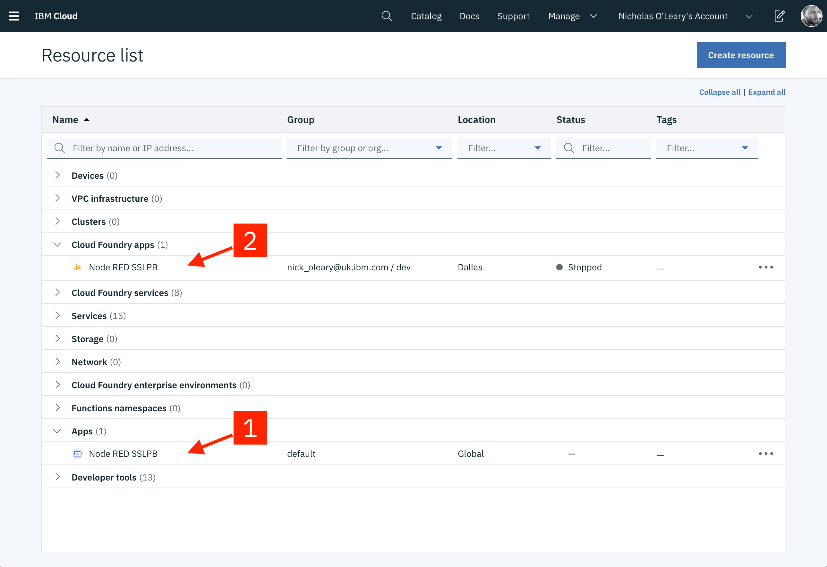9. In the next page, click on Visit App URL.
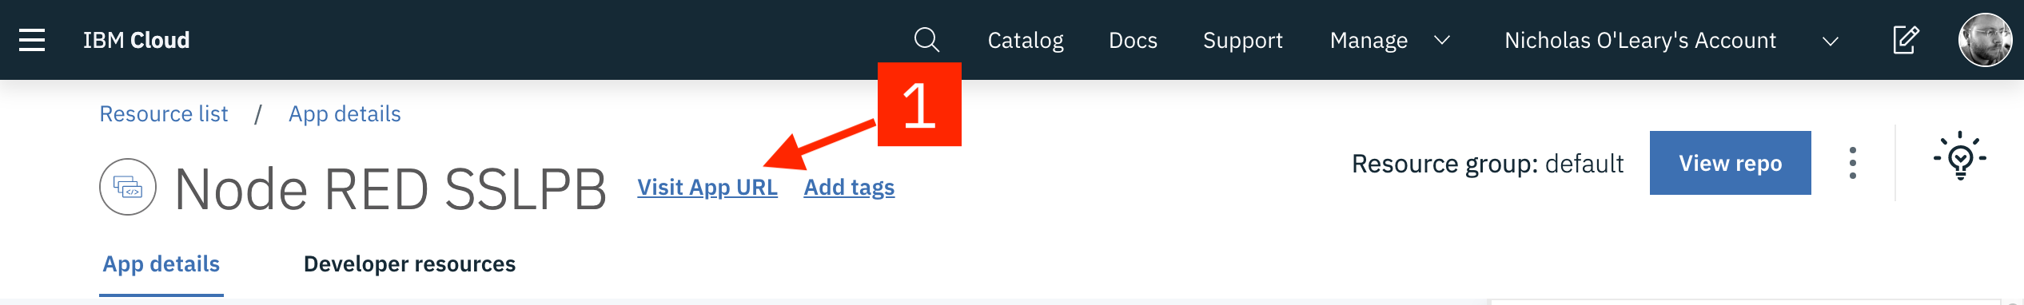
10. Configure by clicking next and then finish and the main page of Node-RED opens.
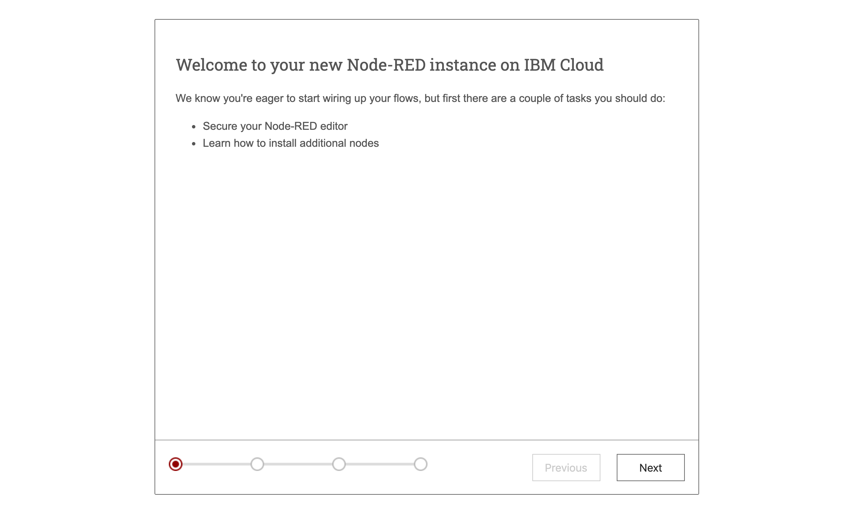

11. Click on Go to your Node-RED flow editor and then flow editor opens.
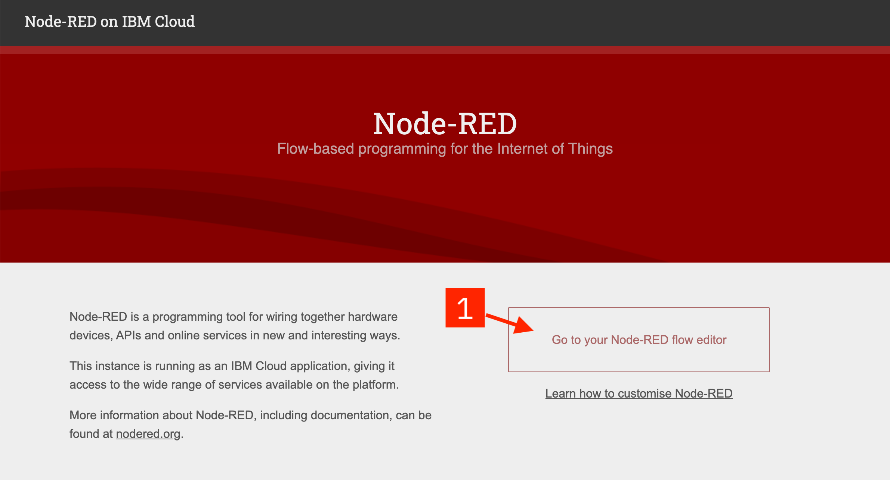

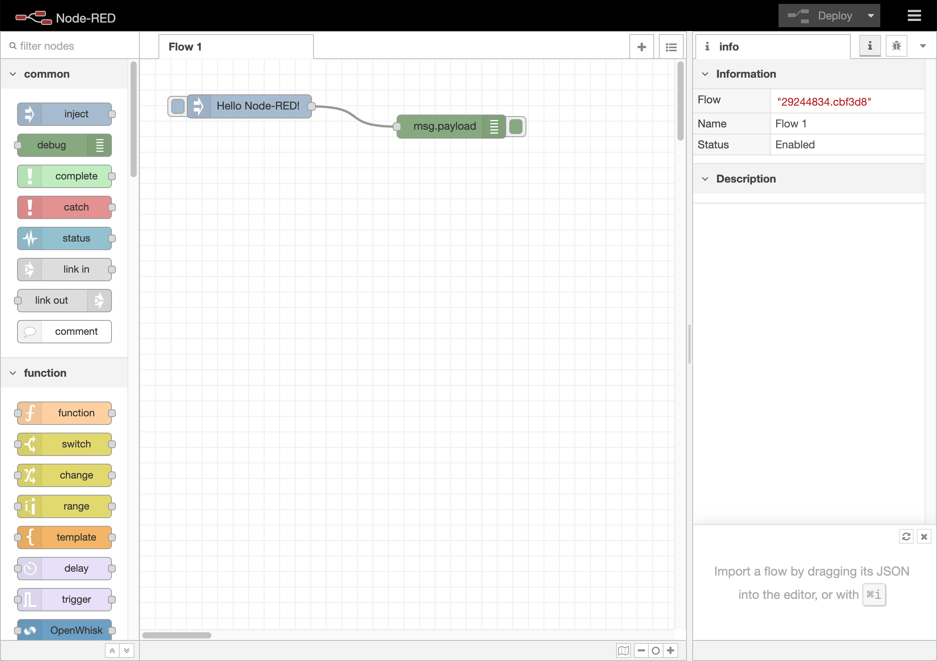

12. Name your flow and build the flow as per requirements and search for Personality Insights node in the palette (on left) and drag it on to the flow editor.
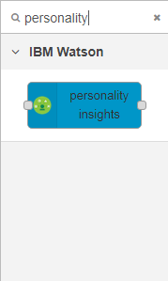

13. Double click on the node and enter the Service Endpoint (URL) and API Key that were saved earlier and choose Input and Response languages.
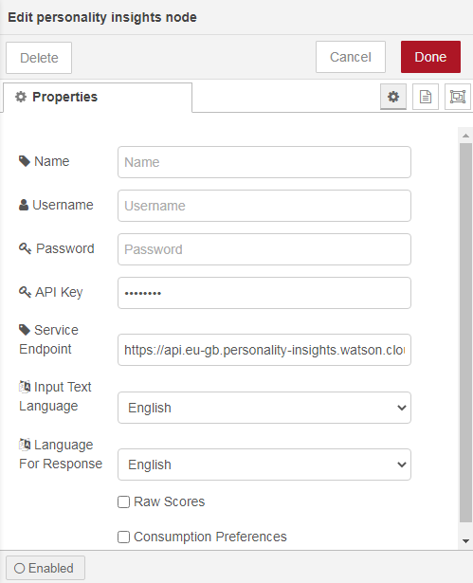
14. Also search for Cloudant nodes in the palette (on left) and drag them on to the flow editor.
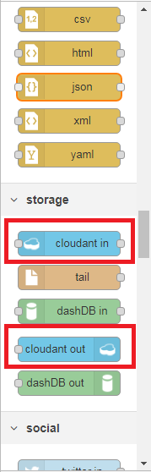

15. Open Clodant in and Cloudant out nodes and configure them with the database name and design all the required connections as per requirements.
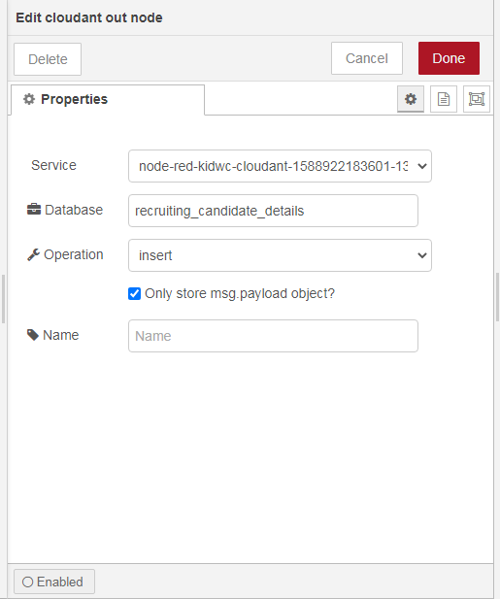
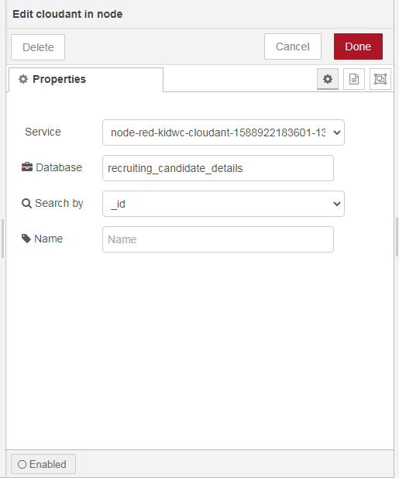

16. After completing the flow click on Deploy (top right) and in the dashboard panel (on right), click on external link icon. This will take to the User Interface where candidates can sign up and login to start their interview.
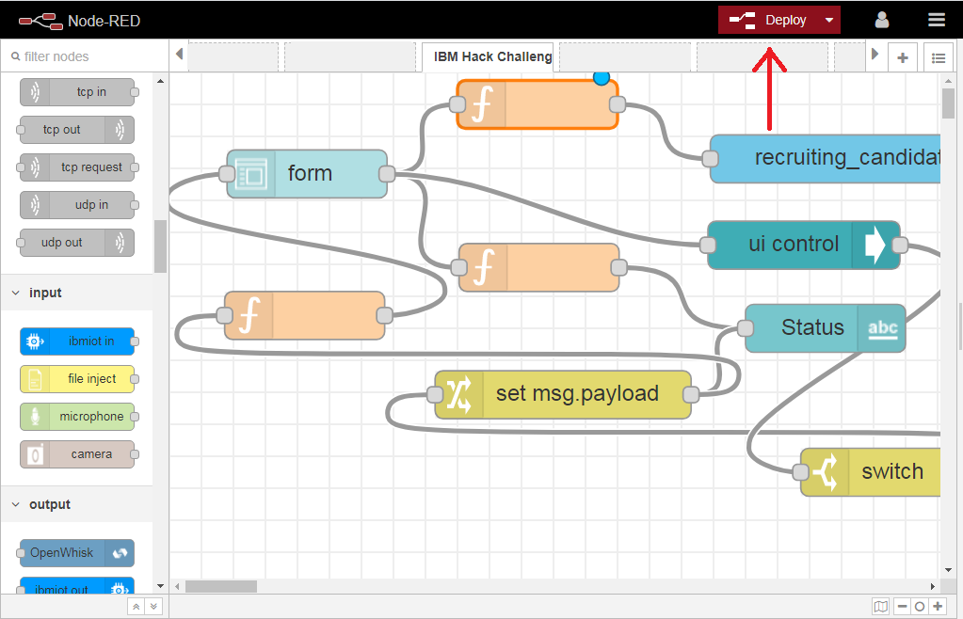
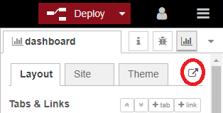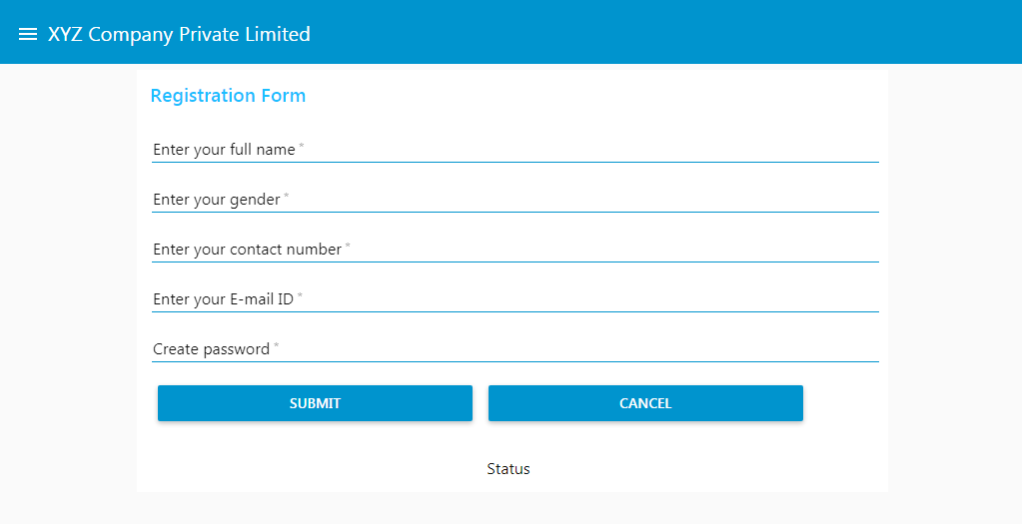

CHAPTER 5
FLOWCHART
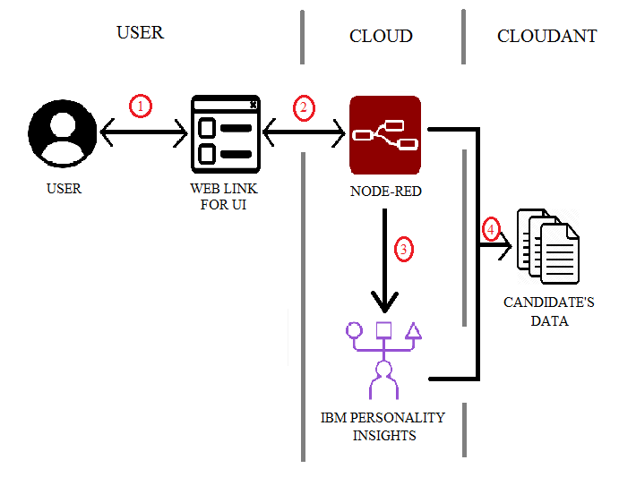

Fig. 5.1 Architecture of Artificial Intelligence (AI) Recruiter using Node-RED

1. The user or candidate submits the form through UI with the help of web link.
2. The information entered by the user is processed in Node-RED and stored in the Cloudant.
3. Some specific data is sent to Personality Insights service to get the insights about the candidate and this gets stored in the Cloudant under the specific candidate document and can be used for reviewing by the recruiter and get an understanding about the candidate.

CHAPTER 6
RESULTS
The candidate can provide or share his information, skills known, and traits through the user-friendly User Interface. The following images show how this process of screening the right candidate is carried out. Once if a candidate gets signed up he can start taking the interview by logging in through the registered mail. The candidate can only take the interview once and cannot retake once submitted and this unique feature adds security and prevents the system from being manipulated by trying to attempt multiple times. After submitting the form depending upon the responses by the candidate, he will be judged if eligible criterion is met. The following images describe the process.

1. Candidate can register for the interview through Registration Form by providing the personal information about the candidate and by clicking Submit.
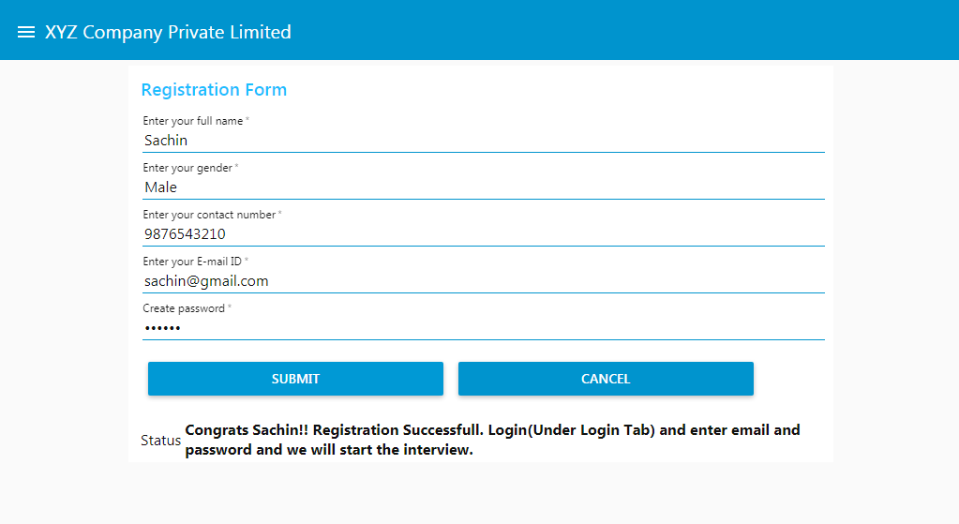

2. In Login page, login with registered mail and password and click Submit and then click Start.
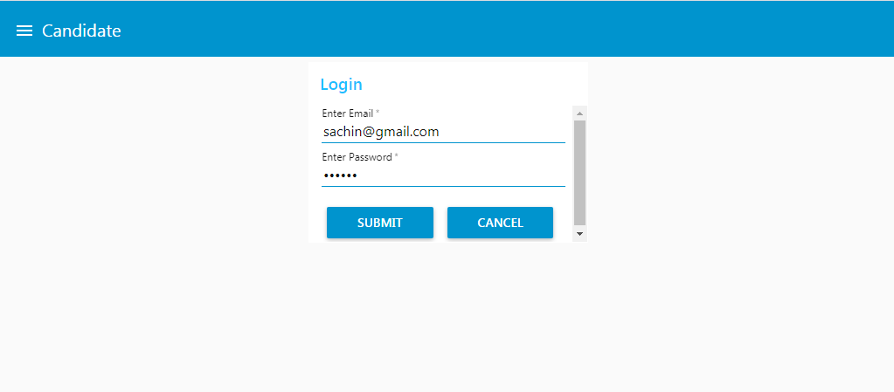
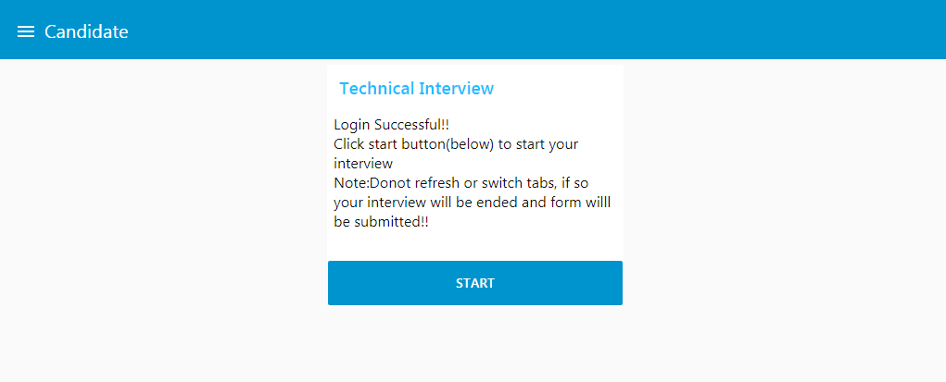

3. Answer the questions and click Submit, and if qualified (eligible criterion is met) a notification message will be displayed with the percentage scored and displays not selected if not eligible.

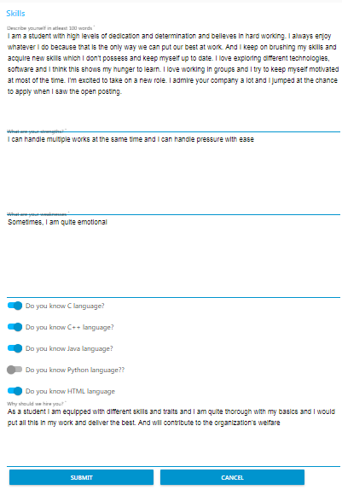


4. The data user entered and the insights generated by Personality Insights will be stored in the Cloudant with a unique document for each candidate. This can be reviewed by recruiter and can make judgements about the candidate based upon his skills and traits and personality generated by Personality Insights.
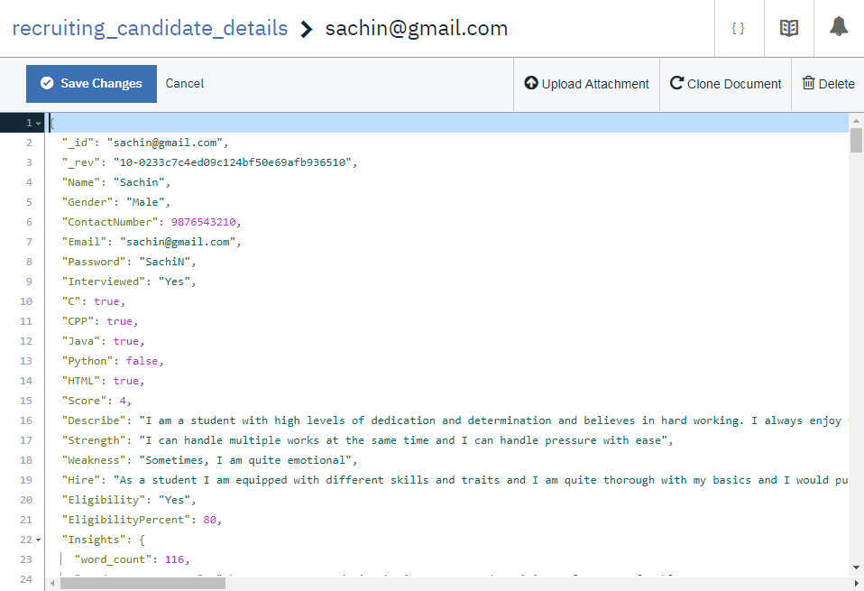
5. Insights generated are displayed in the image below with percentile for each trait.
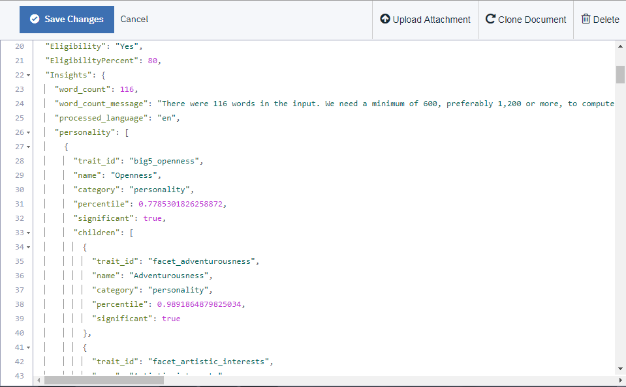

CHAPTER 7
ADVANTAGES AND DISADVANTAGES

ADVANTAGES
- It is cost-efficient and organizations need not invest much in recruiters for picking or selecting the right candidate for the job.
- It brings valuable insights about the characteristics of a person which a human cannot.
- Reduce the involvement of human recruiters.
- Helps the employers in selecting the right candidate for specific job role.
- It reduces the time needed to screen any number of candidates.
- It can take its own decision depending upon the score of the candidate. However, the threshold score required to qualify can be set by the recruiter.
- Almost all industries, companies can deploy AI Recruiter to help the recruiters and speed up the recruiting process with greater efficiency.
- It reduces human recruiters’ effort.
- Data will be stored and can be used for future references.

DISADVANTAGES
- The percentiles generated by Insights are based on the answers of the candidate and sometimes the percentiles might not reflect the original character of the candidate.
- Sometimes these can be manipulated if the working of this model is known.
- It does not consider human emotions.
- Jobs for humans, especially recruiters may be decreased or lost completely.
- Lack of standardization in human text.

CHAPTER 8
APPLICATIONS
AI Recruiters in near future can become a boon to organizations or companies in screening process for a job or selecting candidates for the job directly. Thus it reduces the human effort and moreover helps organization in preserving their resources like money, time and energy and creates a best way to interview the candidates even without the intervention of human more effectively, efficiently and productively. It can also be used by colleges in place of entry exams to select the students. It can be used in different industries like:
- Software Companies.
- Hardware Jobs.
- Mechanical and Electronic Companies.
- Government Jobs.
- And even can replace various college entry exams.

CHAPTER 9
CONCLUSION
For high volume recruiting or scenarios where number of jobs available to number of candidates applied is very low organizations or companies need to interview a large group to select the right candidate. This not only consumes a lot of time but also consumes a lot of money, energy and other resources. According to a survey, almost 65% of candidates’ resumes go unnoticed. Thus, AI Recruiters can solve this issue and can interact with candidates in very short time and bring insights about the traits and characteristics to the recruiter and helps in selecting the right candidate with ease. It also increases the effectiveness and efficiency of recruiters or employers. This can be made possible using AI service like IBM Personality Insights and can screen the candidates with ease. And also, the clear and detailed insights that IBM Personality Insights generate for different characteristics, traits and needs makes the process much unique as humans generally cannot make understanding to this extent that too with accurate percentiles.

CHAPTER 10
FUTURE SCOPE
AI Recruiter is based on text and typing but in future these can be integrated with virtual assistants like Alexa, Google and can resemble much like a human and makes the interaction more convenient and comfortable. So these AI recruiters can be redesigned more conveniently and can be made hands-free. Using speech to text converters, the speech can be converted to text and can be fed to the IBM Personality Insights to generate detail insights about the candidate. AI Recruiter can filter out the eligible candidates faster and human recruiters can interview them if needed. This eases the human recruiter and employers’ in either screening or selecting the right candidate for the specific job.

CHAPTER 11
BIBILOGRAPHY
REFERENCES
- https://cloud.ibm.com/
- https://ideal.com/recruitment-chatbot/
- https://youtube.com/ (IBM Channel)

APPENDIX
SOURCE CODE

- NODE-RED FLOW JSON CODE
[{"id":"9fdfb97d.8f4818","type":"tab","label":"IBM Hack Challenge-Assitant and Cloudant","disabled":false,"info":""},{"id":"871927ef.3608c8","type":"cloudant out","z":"9fdfb97d.8f4818","name":"","cloudant":"","database":"recruiting_candidate_details","service":"node-red-kidwc-cloudant-1588922183601-13926","payonly":true,"operation":"insert","x":458,"y":54,"wires":[]},{"id":"99d7b70b.c52a28","type":"ui_form","z":"9fdfb97d.8f4818","name":"","label":"","group":"7448271.25ab7d8","order":2,"width":0,"height":0,"options":[{"label":"Enter your full name","value":"name","type":"text","required":true,"rows":null},{"label":"Enter your gender","value":"gender","type":"text","required":true,"rows":null},{"label":"Enter your contact number","value":"number","type":"number","required":true,"rows":null},{"label":"Enter your E-mail ID","value":"email","type":"email","required":true,"rows":null},{"label":"Create password","value":"pass","type":"password","required":true,"rows":null}],"formValue":{"name":"","gender":"","number":"","email":"","pass":""},"payload":"","submit":"submit","cancel":"cancel","topic":"","x":86,"y":63.500003814697266,"wires":[["41ae44f8.58959c","81d03ca0.e2d87","d982c91.4efec38"]]},{"id":"41ae44f8.58959c","type":"function","z":"9fdfb97d.8f4818","name":"","func":"msg.payload={\n _id:msg.payload.email,\n Name:msg.payload.name,\n Gender:msg.payload.gender,\n ContactNumber:msg.payload.number,\n Email:msg.payload.email,\n Password:msg.payload.pass,\n Interviewed:\"No\"\n}\nreturn msg;","outputs":1,"noerr":0,"x":234,"y":20,"wires":[["871927ef.3608c8"]]},{"id":"81d03ca0.e2d87","type":"function","z":"9fdfb97d.8f4818","name":"","func":"msg.payload=\"Congrats \"+msg.payload.name+\"!! Registration Successfull. Login(Under Login Tab) and enter email and password and we will start the interview.\"\nreturn msg;","outputs":1,"noerr":0,"x":231,"y":122,"wires":[["b99a404a.6f163"]]},{"id":"b99a404a.6f163","type":"ui_text","z":"9fdfb97d.8f4818","group":"7448271.25ab7d8","order":0,"width":0,"height":0,"name":"","label":"Status","format":"{{msg.payload}}","layout":"row-center","x":410,"y":160,"wires":[]},{"id":"74015cfd.e66534","type":"ui_form","z":"9fdfb97d.8f4818","name":"","label":"","group":"71d5f991.1f8558","order":1,"width":0,"height":0,"options":[{"label":"Enter Email","value":"email","type":"email","required":true,"rows":null},{"label":"Enter Password","value":"pass","type":"password","required":true,"rows":null}],"formValue":{"email":"","pass":""},"payload":"","submit":"submit","cancel":"cancel","topic":"","x":104,"y":438,"wires":[["641f4b30.931574","aab874c5.0bb538"]]},{"id":"641f4b30.931574","type":"function","z":"9fdfb97d.8f4818","name":"","func":"global.set(\"email\",msg.payload.email);\nglobal.set(\"pass\",msg.payload.pass);\nreturn msg;","outputs":1,"noerr":0,"x":217.77780363294812,"y":362.2222551769681,"wires":[["522818ee.6335f8"]]},{"id":"40edeea2.a6f4d","type":"cloudant in","z":"9fdfb97d.8f4818","name":"","cloudant":"","database":"recruiting_candidate_details","service":"node-red-kidwc-cloudant-1588922183601-13926","search":"_id_","design":"","index":"","x":460,"y":400,"wires":[["b2355124.bcb4d","f17a9343.c374e"]]},{"id":"522818ee.6335f8","type":"function","z":"9fdfb97d.8f4818","name":"","func":"var email=global.get(\"email\")\nmsg.payload={\n \"_id\":email\n}\nreturn msg;","outputs":1,"noerr":0,"x":285.55555555555554,"y":494.4444444444445,"wires":[["40edeea2.a6f4d"]]},{"id":"b2355124.bcb4d","type":"function","z":"9fdfb97d.8f4818","name":"","func":"var pass=global.get(\"pass\")\nglobal.set(\"id\",msg.payload._id)\nglobal.set(\"rev\",msg.payload._rev)\nglobal.set(\"Name\",msg.payload.Name)\nglobal.set(\"Interviewed\",msg.payload.Interviewed)\nstate=\"Login Failed\"\nif(msg.payload.Password==pass && msg.payload.Interviewed==\"No\"){\n state=\"Congrats \"+msg.payload.Name+\"!! Login Successful! Answer the question in Technical Interview tab to know whether you are eligible or not\"\n msg.payload=state;\n}\nelse{\n if(msg.payload.Interviewed==\"Yes\" && msg.payload.Password==pass){\n msg.payload=\"Already Interviewed\"\n }\n else{\n if(msg.payload.Password!=pass){\n msg.payload=state\n }\n }\n}\nreturn msg;","outputs":1,"noerr":0,"x":557.8055725097656,"y":540.8611450195312,"wires":[["750924a8.5f231c"]]},{"id":"750924a8.5f231c","type":"switch","z":"9fdfb97d.8f4818","name":"","property":"payload","propertyType":"msg","rules":[{"t":"eq","v":"Already Interviewed","vt":"str"},{"t":"eq","v":"Login Failed","vt":"str"},{"t":"else"}],"checkall":"true","repair":false,"outputs":3,"x":674.5,"y":582,"wires":[["fe88b98.949a748"],["d3db6ec2.0778b"],["b4594f0e.9335e"]]},{"id":"d3db6ec2.0778b","type":"change","z":"9fdfb97d.8f4818","name":"","rules":[{"t":"set","p":"payload","pt":"msg","to":"{\"group\":{\"hide\":[\"Candidate_Login\",\"Candidate_Technical_Interview\",\"Candidate_Skills\",\"Candidate_Interview_Failed\",\"Candidate_Interview_Success!!!\",\"Candidate_Already_Interviewed\",\"Candidate_Email_Not_Registered\"],\"show\":[\"Candidate_Alert\"]}}","tot":"json"}],"action":"","property":"","from":"","to":"","reg":false,"x":860.5,"y":580,"wires":[["5fcf6a39.3b9ff4"]]},{"id":"5fcf6a39.3b9ff4","type":"ui_ui_control","z":"9fdfb97d.8f4818","name":"","events":"all","x":1071.77783203125,"y":577.5555419921875,"wires":[["c4701870.df78a8"]]},{"id":"b4594f0e.9335e","type":"change","z":"9fdfb97d.8f4818","name":"","rules":[{"t":"set","p":"payload","pt":"msg","to":"{\"group\":{\"hide\":[\"Candidate_Login\",\"Candidate_Alert\",\"Candidate_Skills\",\"Candidate_Interview_Failed\",\"Candidate_Interview_Success!!!\",\"Candidate_Already_Interviewed\",\"Candidate_Email_Not_Registered\"],\"show\":[\"Candidate_Technical_Interview\"]}}","tot":"json"}],"action":"","property":"","from":"","to":"","reg":false,"x":858.6666870117188,"y":627.6666870117188,"wires":[["5fcf6a39.3b9ff4"]]},{"id":"7a1af1b0.55967","type":"ui_template","z":"9fdfb97d.8f4818","group":"db8be15d.63a52","name":"","order":1,"width":0,"height":0,"format":"Wrong Credentials!","storeOutMessages":true,"fwdInMessages":true,"resendOnRefresh":false,"templateScope":"local","x":1011.7142333984375,"y":57.428558349609375,"wires":[[]]},{"id":"8b0f81df.03882","type":"inject","z":"9fdfb97d.8f4818","name":"","topic":"","payload":"{\"group\":{\"hide\":[\"Candidate_Technical_Interview\",\"Candidate_Alert\",\"Candidate_Skills\",\"Candidate_Interview_Failed\",\"Candidate_Interview_Success!!!\",\"Candidate_Already_Interviewed\",\"Candidate_Email_Not_Registered\"],\"show\":[\"Candidate_Login\"]}}","payloadType":"json","repeat":"3600","crontab":"","once":true,"onceDelay":"10","x":869.2857856750488,"y":387.14295196533203,"wires":[[]]},{"id":"d6a72b27.110768","type":"ui_template","z":"9fdfb97d.8f4818","group":"af44fa85.3cb8b8","name":"","order":1,"width":0,"height":0,"format":"Login Successful!!<br/>\nClick start button(below) to start your interview<br/>\nNote:Donot refresh or switch tabs, if so your interview will be ended and form willl be submitted!!\n","storeOutMessages":true,"fwdInMessages":true,"resendOnRefresh":false,"templateScope":"local","x":1008.5714111328125,"y":109.85714721679688,"wires":[[]]},{"id":"e52e5100.83fdc","type":"ui_button","z":"9fdfb97d.8f4818","name":"","group":"db8be15d.63a52","order":2,"width":0,"height":0,"passthru":false,"label":"Try Again","tooltip":"","color":"","bgcolor":"","icon":"","payload":"{\"group\":{\"hide\":[\"Candidate_Technical_Interview\",\"Candidate_Alert\",\"Candidate_Skills\",\"Candidate_Interview_Failed\",\"Candidate_Interview_Success!!!\",\"Candidate_Email_Not_Registered\"],\"show\":[\"Candidate_Login\"]}}","payloadType":"json","topic":"","x":1016.9998779296875,"y":736.1428833007812,"wires":[["5fcf6a39.3b9ff4"]]},{"id":"5fbd9671.7fe928","type":"ui_button","z":"9fdfb97d.8f4818","name":"","group":"af44fa85.3cb8b8","order":2,"width":0,"height":0,"passthru":false,"label":"Start","tooltip":"","color":"","bgcolor":"","icon":"","payload":"{\"group\":{\"hide\":[\"Candidate_Login\",\"Candidate_Technical_Interview\",\"Candidate_Alert\",\"Candidate_Interview_Failed\",\"Candidate_Interview_Success!!!\",\"Candidate_Already_Interviewed\",\"Candidate_Email_Not_Registered\"],\"show\":[\"Candidate_Skills\"]}}","payloadType":"json","topic":"","x":1016.8571166992188,"y":411.8571472167969,"wires":[["5fcf6a39.3b9ff4"]]},{"id":"c4701870.df78a8","type":"switch","z":"9fdfb97d.8f4818","name":"","property":"payload","propertyType":"msg","rules":[{"t":"eq","v":"change","vt":"str"}],"checkall":"true","repair":false,"outputs":1,"x":1223.5,"y":603,"wires":[["9bc78f8a.33d74"]]},{"id":"9bc78f8a.33d74","type":"change","z":"9fdfb97d.8f4818","name":"","rules":[{"t":"set","p":"payload","pt":"msg","to":"{\"group\":{\"hide\":[\"Candidate_Technical_Interview\",\"Candidate_Alert\",\"Candidate_Skills\",\"Candidate_Interview_Failed\",\"Candidate_Interview_Success!!!\",\"Candidate_Already_Interviewed\",\"Candidate_Email_Not_Registered\"],\"show\":[\"Candidate_Login\"]}}","tot":"json"}],"action":"","property":"","from":"","to":"","reg":false,"x":1250.5,"y":686,"wires":[["5fcf6a39.3b9ff4"]]},{"id":"d3a202c.cf631","type":"ui_form","z":"9fdfb97d.8f4818","name":"","label":"","group":"b95f2d1d.9c857","order":0,"width":"0","height":"0","options":[{"label":"Describe yourself in atleast 100 words","value":"describe","type":"multiline","required":true,"rows":5},{"label":"What are your strengths?","value":"strength","type":"multiline","required":true,"rows":4},{"label":"What are your weaknesses","value":"weak","type":"multiline","required":true,"rows":4},{"label":"Do you know C language?","value":"c","type":"switch","required":true,"rows":null},{"label":"Do you know C++ language?","value":"cpp","type":"switch","required":true,"rows":null},{"label":"Do you know Java language?","value":"java","type":"switch","required":true,"rows":null},{"label":"Do you know Python language??","value":"python","type":"switch","required":true,"rows":null},{"label":"Do you know HTML language","value":"html","type":"switch","required":true,"rows":null},{"label":"Why should we hire you?","value":"hire","type":"multiline","required":true,"rows":3}],"formValue":{"describe":"","strength":"","weak":"","c":false,"cpp":false,"java":false,"python":false,"html":false,"hire":""},"payload":"","submit":"submit","cancel":"cancel","topic":"","x":79,"y":787,"wires":[["f705cd.86b1da3","4cb4ff04.e0faa"]]},{"id":"60e07645.dabad8","type":"function","z":"9fdfb97d.8f4818","name":"","func":"var c=global.get(\"c\")\nvar cpp=global.get(\"cpp\")\nvar java=global.get(\"java\")\nvar python=global.get(\"python\")\nvar html=global.get(\"html\")\nvar describe=global.get(\"describe\")\nvar strength=global.get(\"strength\")\nvar weak=global.get(\"weak\")\nvar hire=global.get(\"hire\")\nvar Score=0\nvar insight=global.get(\"insight\")\nmsg.payload.C=c\nif(c===true){\n Score=Score+1\n}\nmsg.payload.CPP=cpp\nif(cpp===true){\n Score=Score+1\n}\nmsg.payload.Java=java\nif(java===true){\n Score=Score+1\n}\nmsg.payload.Python=python\nif(python===true){\n Score=Score+1\n}\nmsg.payload.HTML=html\nif(html===true){\n Score=Score+1\n}\nmsg.payload.Score=Score\nmsg.payload.Describe=describe\nmsg.payload.Strength=strength\nmsg.payload.Weakness=weak\nmsg.payload.Hire=hire\nmsg.payload.Interviewed=\"Yes\"\nmsg.payload.Insights=insight\nif(Score>=3 && msg.payload.Insights.personality[0].percentile>0.5 && msg.payload.Insights.needs[0].percentile>0.5)\n{\n msg.payload.Eligibility=\"Yes\"\n msg.payload.EligibilityPercent=(Score*100)/5\n}\nelse{\n msg.payload.Eligibility=\"No\" \n msg.payload.EligibilityPercent=(Score*100)/5\n}\nglobal.set(\"Eligibility\",msg.payload.Eligibility)\nglobal.set(\"EligibilityPercent\",msg.payload.EligibilityPercent)\nreturn msg;","outputs":1,"noerr":0,"x":420,"y":917,"wires":[["6915e05a.11e9","1ac65c65.9e8fb4","37ac1dc0.cfce82"]]},{"id":"6915e05a.11e9","type":"cloudant out","z":"9fdfb97d.8f4818","name":"","cloudant":"","database":"recruiting_candidate_details","service":"node-red-kidwc-cloudant-1588922183601-13926","payonly":true,"operation":"insert","x":656,"y":816,"wires":[]},{"id":"f705cd.86b1da3","type":"function","z":"9fdfb97d.8f4818","name":"","func":"global.set(\"c\",msg.payload.c);\nglobal.set(\"cpp\",msg.payload.cpp);\nglobal.set(\"java\",msg.payload.java);\nglobal.set(\"python\",msg.payload.python);\nglobal.set(\"html\",msg.payload.html);\nglobal.set(\"describe\",msg.payload.describe);\nglobal.set(\"strength\",msg.payload.strength);\nglobal.set(\"weak\",msg.payload.weak);\nglobal.set(\"hire\",msg.payload.hire);\nvar id=global.get(\"id\")\nmsg.payload={\n \"_id\":id\n}\nreturn msg;","outputs":1,"noerr":0,"x":170,"y":862,"wires":[["c2a12831.800898"]]},{"id":"c2a12831.800898","type":"cloudant in","z":"9fdfb97d.8f4818","name":"","cloudant":"","database":"recruiting_candidate_details","service":"node-red-kidwc-cloudant-1588922183601-13926","search":"_id_","design":"","index":"","x":324,"y":786,"wires":[["60e07645.dabad8"]]},{"id":"1ac65c65.9e8fb4","type":"switch","z":"9fdfb97d.8f4818","name":"","property":"payload.Eligibility","propertyType":"msg","rules":[{"t":"eq","v":"Yes","vt":"str"},{"t":"else"}],"checkall":"true","repair":false,"outputs":2,"x":605,"y":942,"wires":[["58997e37.4cc9a"],["2c2facdd.b52fb4"]]},{"id":"58997e37.4cc9a","type":"change","z":"9fdfb97d.8f4818","name":"","rules":[{"t":"set","p":"payload","pt":"msg","to":"{\"group\":{\"hide\":[\"Candidate_Login\",\"Candidate_Technical_Interview\",\"Candidate_Alert\",\"Candidate_Skills\",\"Candidate_Interview_Failed\",\"Candidate_Already_Interviewed\",\"Candidate_Email_Not_Registered\"],\"show\":[\"Candidate_Interview_Success!!!\"]}}","tot":"json"}],"action":"","property":"","from":"","to":"","reg":false,"x":785.1666259765625,"y":894.6666870117188,"wires":[["b0dbed89.292e7","95b9f5aa.9313e8"]]},{"id":"2c2facdd.b52fb4","type":"change","z":"9fdfb97d.8f4818","name":"","rules":[{"t":"set","p":"payload","pt":"msg","to":"{\"group\":{\"hide\":[\"Candidate_Login\",\"Candidate_Technical_Interview\",\"Candidate_Alert\",\"Candidate_Skills\",\"Candidate_Interview_Success!!!\",\"Candidate_Already_Interviewed\",\"Candidate_Email_Not_Registered\"],\"show\":[\"Candidate_Interview_Failed\"]}}","tot":"json"}],"action":"","property":"","from":"","to":"","reg":false,"x":788,"y":988,"wires":[["b0dbed89.292e7"]]},{"id":"b0dbed89.292e7","type":"ui_ui_control","z":"9fdfb97d.8f4818","name":"","events":"all","x":998.27783203125,"y":838.5555419921875,"wires":[[]]},{"id":"289d551.84496aa","type":"ui_template","z":"9fdfb97d.8f4818","group":"b0f85f9a.2f28d","name":"","order":0,"width":0,"height":0,"format":"Sorry! You didnot qualify. Get yourself ready for next year by acquiring ne skill<br/>\nAll The Best!!","storeOutMessages":true,"fwdInMessages":true,"resendOnRefresh":false,"templateScope":"local","x":1008,"y":218,"wires":[[]]},{"id":"e0052604.46d538","type":"ui_template","z":"9fdfb97d.8f4818","group":"49eefb8b.247bb4","name":"","order":1,"width":0,"height":0,"format":"Success!! Congratulations!!<br/>","storeOutMessages":true,"fwdInMessages":true,"resendOnRefresh":false,"templateScope":"local","x":1008,"y":163,"wires":[[]]},{"id":"95b9f5aa.9313e8","type":"function","z":"9fdfb97d.8f4818","name":"","func":"var eli=global.get(\"Eligibility\")\nvar eliper=global.get(\"EligibilityPercent\")\nvar name=global.get(\"Name\")\nmsg.payload=name+\",you have passed the interview and likely to select for the job. Your percentage is \"+eliper+\"%\"\nreturn msg;","outputs":1,"noerr":0,"x":1004,"y":920,"wires":[["8bfb81f0.c356d"]]},{"id":"8bfb81f0.c356d","type":"ui_text","z":"9fdfb97d.8f4818","group":"49eefb8b.247bb4","order":2,"width":0,"height":0,"name":"","label":"","format":"{{msg.payload}}","layout":"row-spread","x":1162,"y":922,"wires":[]},{"id":"6ac4ad0f.546524","type":"switch","z":"9fdfb97d.8f4818","name":"","property":"payload","propertyType":"msg","rules":[{"t":"eq","v":"change","vt":"str"}],"checkall":"true","repair":false,"outputs":1,"x":444.50000762939453,"y":250.00000381469727,"wires":[["3cf2a52c.935b1a"]]},{"id":"3cf2a52c.935b1a","type":"change","z":"9fdfb97d.8f4818","name":"","rules":[{"t":"set","p":"payload","pt":"msg","to":"","tot":"str"}],"action":"","property":"","from":"","to":"","reg":false,"x":246.00000762939453,"y":201.50000381469727,"wires":[["b99a404a.6f163","5dec4dde.de0084"]]},{"id":"d982c91.4efec38","type":"ui_ui_control","z":"9fdfb97d.8f4818","name":"","events":"all","x":396.5,"y":108,"wires":[["6ac4ad0f.546524"]]},{"id":"5dec4dde.de0084","type":"function","z":"9fdfb97d.8f4818","name":"","func":"\nreturn msg;","outputs":1,"noerr":0,"x":84.50000381469727,"y":152.00000381469727,"wires":[["99d7b70b.c52a28"]]},{"id":"aab874c5.0bb538","type":"ui_ui_control","z":"9fdfb97d.8f4818","name":"","events":"all","x":216,"y":543,"wires":[["1df9f4e3.01a9fb"]]},{"id":"1df9f4e3.01a9fb","type":"switch","z":"9fdfb97d.8f4818","name":"","property":"payload","propertyType":"msg","rules":[{"t":"eq","v":"change","vt":"str"}],"checkall":"true","repair":false,"outputs":1,"x":266,"y":601.5,"wires":[["8847a438.28aee8"]]},{"id":"8847a438.28aee8","type":"function","z":"9fdfb97d.8f4818","name":"","func":"\nreturn msg;","outputs":1,"noerr":0,"x":120,"y":676,"wires":[["74015cfd.e66534"]]},{"id":"543c75b.b90948c","type":"watson-personality-insights-v3","z":"9fdfb97d.8f4818","name":"","inputlang":"en","outputlang":"en","rawscores":false,"consumption":false,"service-endpoint":"https://api.eu-gb.personality-insights.watson.cloud.ibm.com/instances/1f1bc59f-f3ee-4e8f-be07-a9e1f15e87fe","x":247,"y":998,"wires":[["c925b8c7.b8f0c8"]]},{"id":"4cb4ff04.e0faa","type":"function","z":"9fdfb97d.8f4818","name":"","func":"global.set(\"describe\",msg.payload.describe);\nvar describe=global.get(\"describe\")\nmsg.payload=describe\nreturn msg;","outputs":1,"noerr":0,"x":167,"y":941,"wires":[["543c75b.b90948c"]]},{"id":"fe88b98.949a748","type":"change","z":"9fdfb97d.8f4818","name":"","rules":[{"t":"set","p":"payload","pt":"msg","to":"{\"group\":{\"hide\":[\"Candidate_Login\",\"Candidate_Technical_Interview\",\"Candidate_Alert\",\"Candidate_Skills\",\"Candidate_Interview_Failed\",\"Candidate_Interview_Success!!!\",\"Candidate_Email_Not_Registered\"],\"show\":[\"Candidate_Already_Interviewed\"]}}","tot":"json"}],"action":"","property":"","from":"","to":"","reg":false,"x":859.5,"y":530,"wires":[["5fcf6a39.3b9ff4"]]},{"id":"d87fd83f.8821b8","type":"ui_template","z":"9fdfb97d.8f4818","group":"79eb3e39.b1606","name":"","order":0,"width":0,"height":0,"format":"Sorry! You cannot login back because you were already interviewed","storeOutMessages":true,"fwdInMessages":true,"resendOnRefresh":false,"templateScope":"local","x":1009,"y":274,"wires":[[]]},{"id":"b52cc7c9.fba7e8","type":"change","z":"9fdfb97d.8f4818","name":"","rules":[{"t":"set","p":"payload","pt":"msg","to":"{\"group\":{\"hide\":[\"Candidate_Login\",\"Candidate_Technical_Interview\",\"Candidate_Alert\",\"Candidate_Skills\",\"Candidate_Interview_Failed\",\"Candidate_Interview_Success!!!\",\"Candidate_Already_Interviewed\"],\"show\":[\"Candidate_Email_Not_Registered\"]}}","tot":"json"}],"action":"","property":"","from":"","to":"","reg":false,"x":859.5,"y":709,"wires":[["5fcf6a39.3b9ff4"]]},{"id":"b072fd3c.8be3d","type":"ui_template","z":"9fdfb97d.8f4818","group":"baee86b.bf59978","name":"","order":1,"width":0,"height":0,"format":"Sorry! ID not found, either you entered it wrong or have not registered yet!","storeOutMessages":true,"fwdInMessages":true,"resendOnRefresh":false,"templateScope":"local","x":1009,"y":328,"wires":[[]]},{"id":"b940adc7.015db","type":"ui_button","z":"9fdfb97d.8f4818","name":"","group":"baee86b.bf59978","order":2,"width":0,"height":0,"passthru":false,"label":"Try Again","tooltip":"","color":"","bgcolor":"","icon":"","payload":"{\"group\":{\"hide\":[\"Candidate_Technical_Interview\",\"Candidate_Alert\",\"Candidate_Skills\",\"Candidate_Interview_Failed\",\"Candidate_Interview_Success!!!\",\"Candidate_Email_Not_Registered\"],\"show\":[\"Candidate_Login\"]}}","payloadType":"json","topic":"","x":1106,"y":509,"wires":[["5fcf6a39.3b9ff4"]]},{"id":"f17a9343.c374e","type":"switch","z":"9fdfb97d.8f4818","name":"","property":"payload","propertyType":"msg","rules":[{"t":"eq","v":"payload.null","vt":"msg"}],"checkall":"true","repair":false,"outputs":1,"x":673.5,"y":701,"wires":[["b52cc7c9.fba7e8"]]},{"id":"c925b8c7.b8f0c8","type":"function","z":"9fdfb97d.8f4818","name":"","func":"msg.payload=msg.insights\nglobal.set(\"insight\",msg.payload)\nreturn msg;","outputs":1,"noerr":0,"x":436,"y":1002,"wires":[[]]},{"id":"37ac1dc0.cfce82","type":"debug","z":"9fdfb97d.8f4818","name":"","active":true,"tosidebar":true,"console":false,"tostatus":false,"complete":"false","x":610,"y":1020,"wires":[]},{"id":"7448271.25ab7d8","type":"ui_group","z":"","name":"Registration Form","tab":"be52855e.26ea78","order":1,"disp":true,"width":"14","collapse":false},{"id":"71d5f991.1f8558","type":"ui_group","z":"","name":"Login","tab":"7d09c35.a2c983c","order":1,"disp":true,"width":"6","collapse":false},{"id":"db8be15d.63a52","type":"ui_group","z":"","name":"Alert","tab":"7d09c35.a2c983c","order":4,"disp":true,"width":"6","collapse":false},{"id":"af44fa85.3cb8b8","type":"ui_group","z":"","name":"Technical Interview","tab":"7d09c35.a2c983c","order":3,"disp":true,"width":"6","collapse":false},{"id":"b95f2d1d.9c857","type":"ui_group","z":"","name":"Skills","tab":"7d09c35.a2c983c","order":4,"disp":true,"width":"15","collapse":false},{"id":"b0f85f9a.2f28d","type":"ui_group","z":"","name":"Interview Failed","tab":"7d09c35.a2c983c","order":5,"disp":true,"width":"6","collapse":false},{"id":"49eefb8b.247bb4","type":"ui_group","z":"","name":"Interview Success!!!","tab":"7d09c35.a2c983c","order":6,"disp":true,"width":"6","collapse":false},{"id":"79eb3e39.b1606","type":"ui_group","z":"","name":"Already Interviewed","tab":"7d09c35.a2c983c","order":7,"disp":true,"width":"6","collapse":false},{"id":"baee86b.bf59978","type":"ui_group","z":"","name":"Email Not Registered","tab":"7d09c35.a2c983c","order":8,"disp":true,"width":"6","collapse":false},{"id":"be52855e.26ea78","type":"ui_tab","z":"","name":"XYZ Company Private Limited","icon":"dashboard","disabled":false,"hidden":false},{"id":"7d09c35.a2c983c","type":"ui_tab","z":"","name":"Candidate","icon":"dashboard","disabled":false,"hidden":false}]

